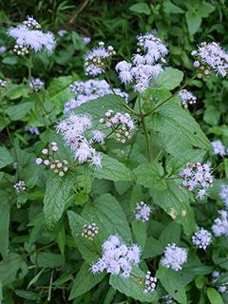
Blue Mist Flower Conoclinium coelestinum

*Part-sun to part-shade
*3ft tall *Deer/Rabbit resistant *Resilient native perennial can and will spread *Great for a variety of insects providing nectar during the dearth of late summer

